Jefferson Bui

CMPSC 221

2020/04/14

Assignment 3

Question 1:

Part 1: GUI

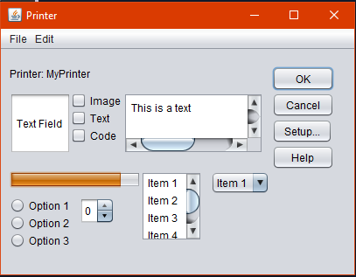

Creating Printer GUI.

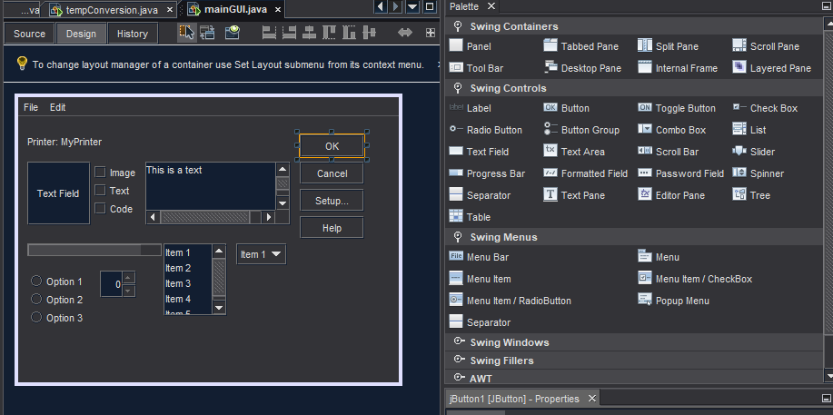

Components added using the wizard.

Part 2: Temperature Conversion Application

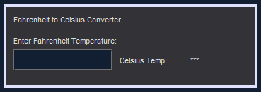

Created Temperature Conversion GUI

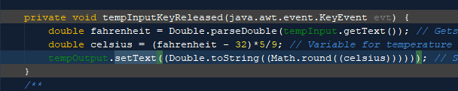

Key Released input action method created with 2 variables for the temp conversion: Fahrenheit (double) and Celsius (double).

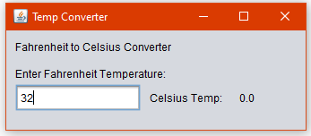

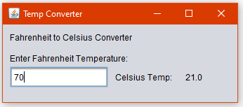

Celsius Temp gets updated as the user enters in numbers.

Part 3: Keyboard Application

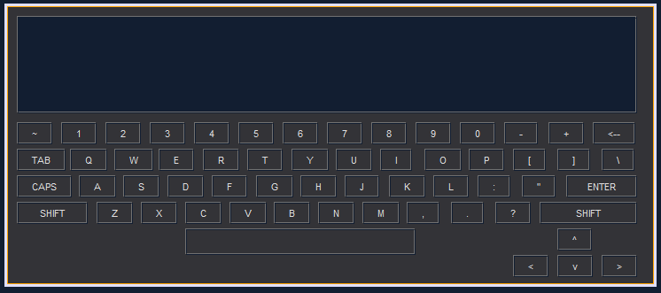

Created Keyboard GUI

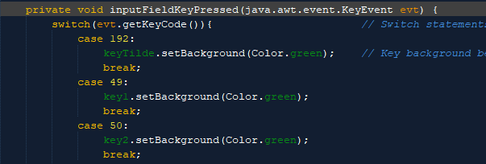

Key Pressed input action method created. Used switch and cases for each key being pressed. We know which key is being pressed with getKeyCode. Upon pressing down on the key, it is lit up as green.

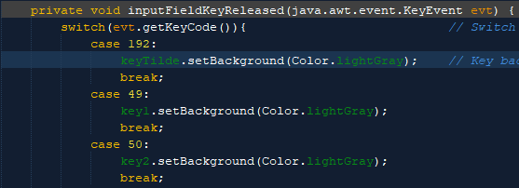

Key Released input action method created. Used switch and cases for each key released. We know what key is released using getKeyCode. When the key is released, it revert back to its default key color.

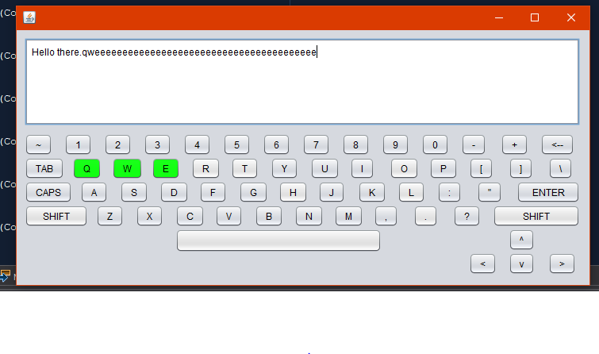

Keys pressed and keys not pressed.

Question 2: AuthorBookCRUD GUI

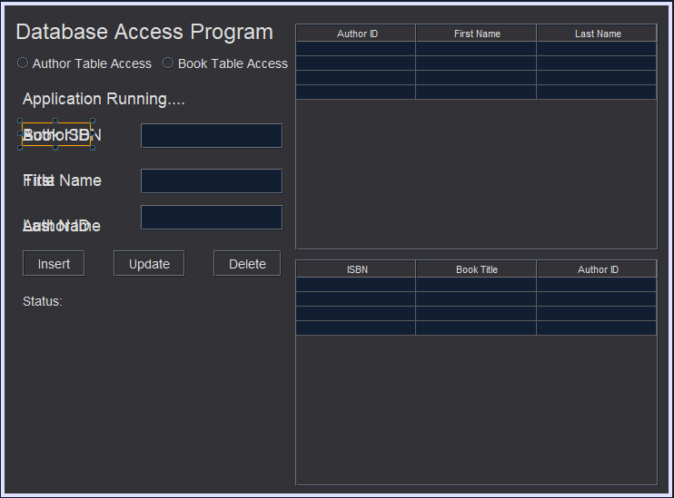

Created GUI for AuthorBookCRUD

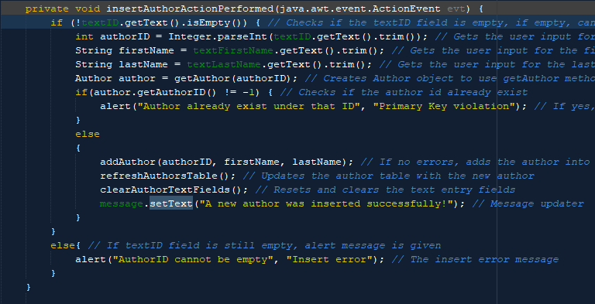

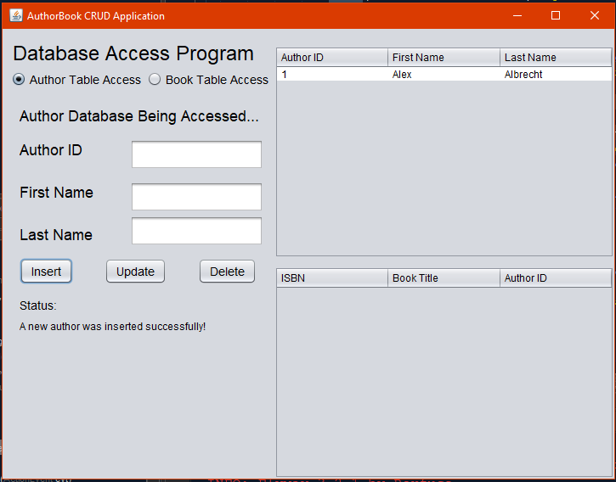

insertAuthorActionPerformed method was added to insert authors into database.

Added a new author into the database for author table.

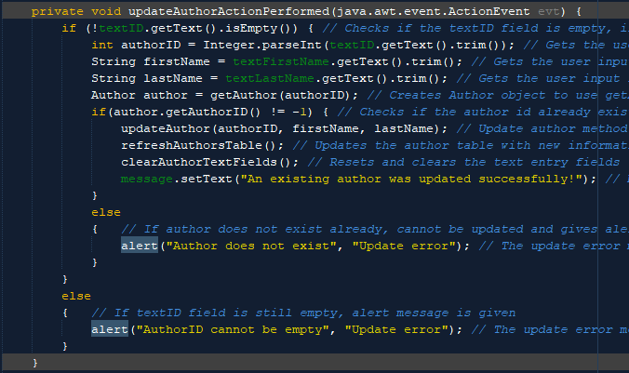

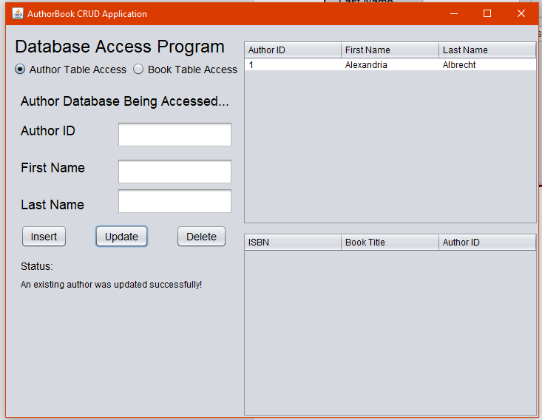

updateAuthorActionPerformed method was added to update authors into database.

Updated an existing author in the database for the author table.

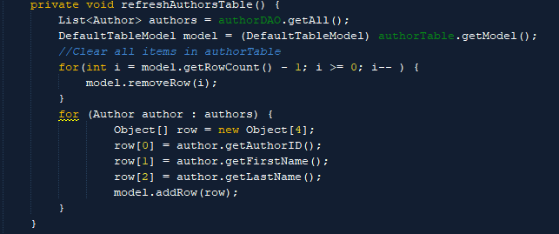

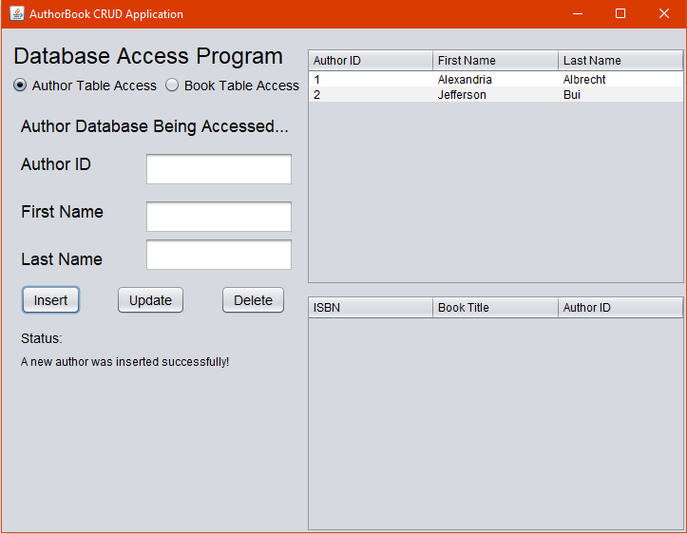

refreshAuthorsTable method allows for the author table to update when called.

Author list is shown on the side and updated after each action that is performed.

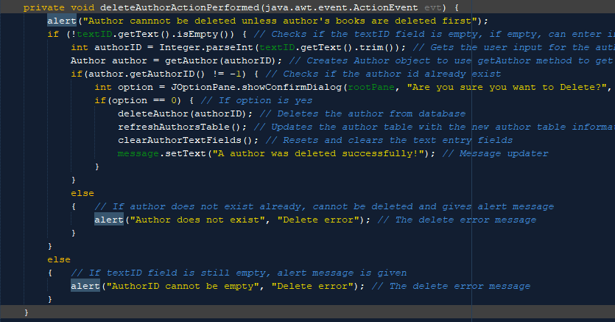

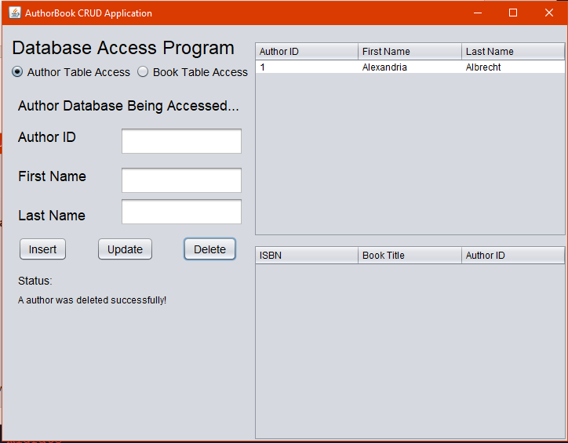

deleteAuthorActionPerformed method was added to delete authors from database.

Deleted an existing author in the database for author table.

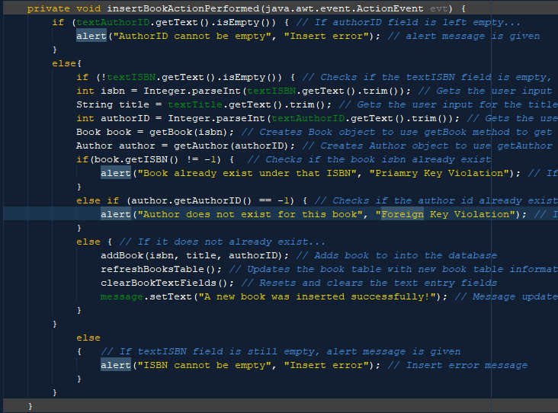

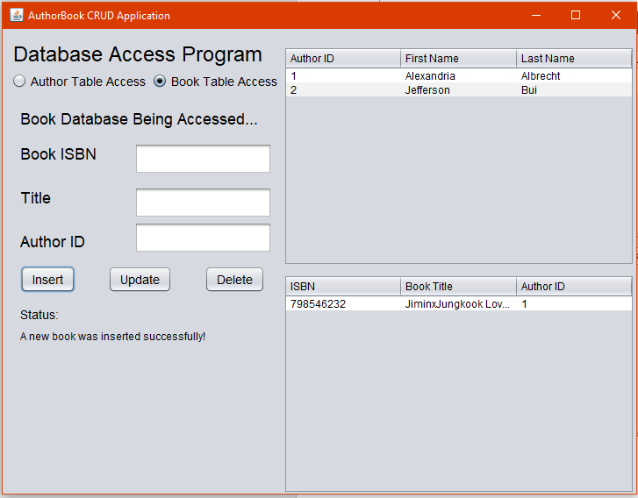

insertBookActionPerformed method was added to insert books into database.

Added a new book into the database for book table.

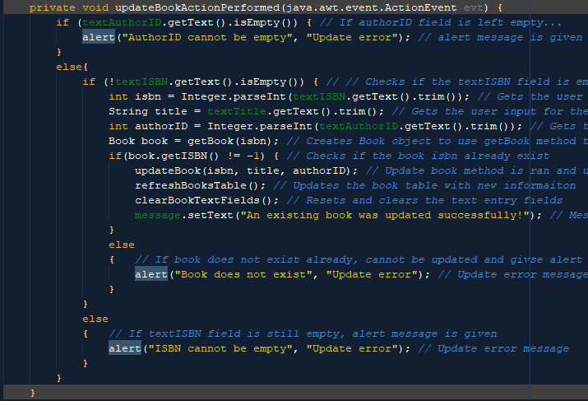

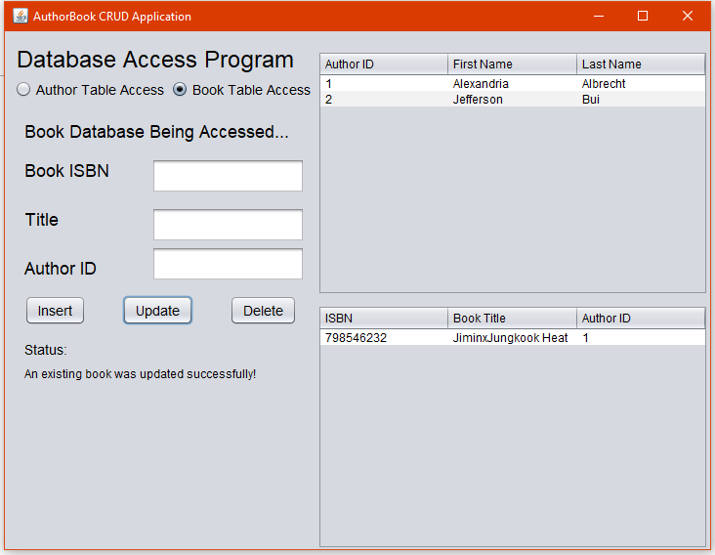

updateBookActionPerformed method was added to update books into database.

Updated an existing book in the database for the book table.

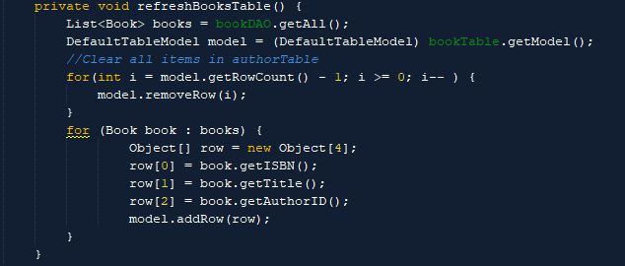

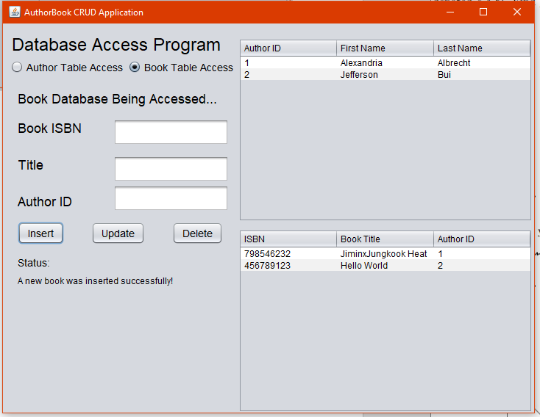

refreshBooksTable method allows for the book table to update when called.

Book list is shown on the side and updated after each action that is performed.

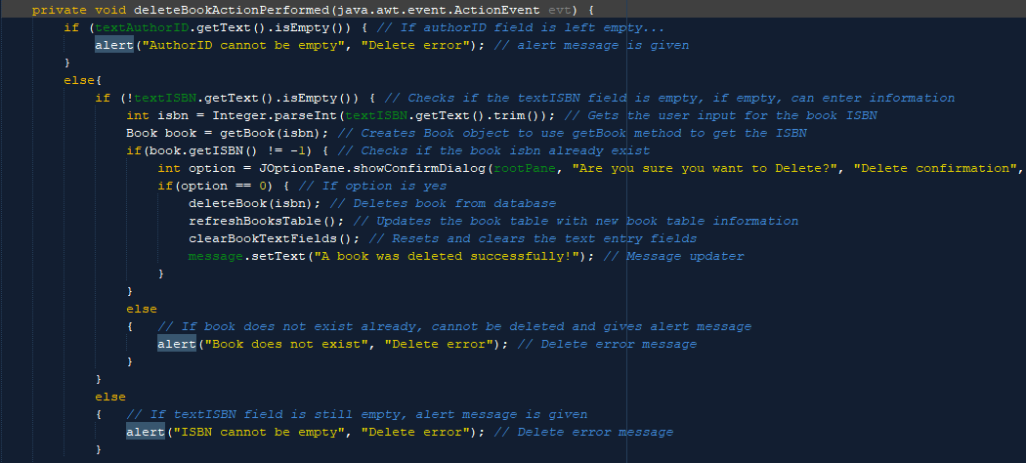

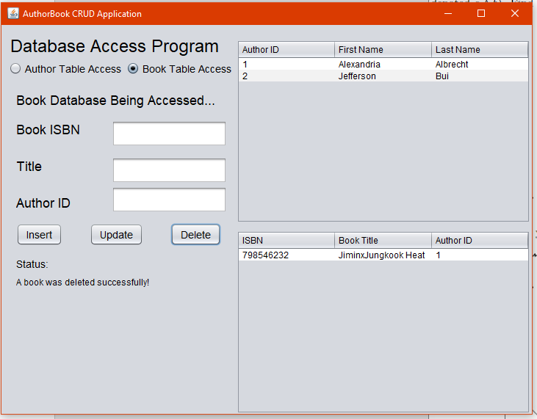

deleteBookActionPerformed method was added to delete books from database.

Deleted an existing book in database for book table.

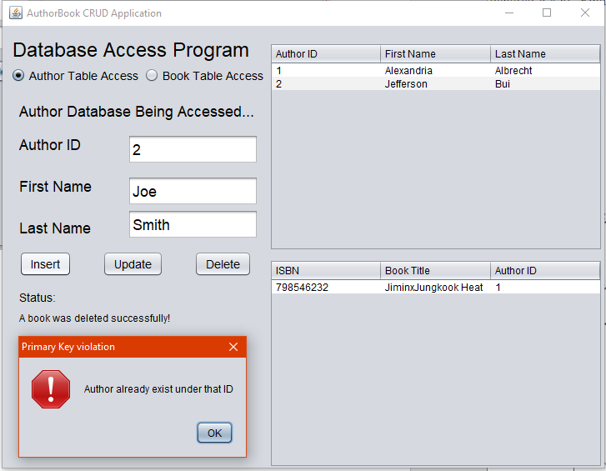

Added new author with existing ID for a primary key violation.

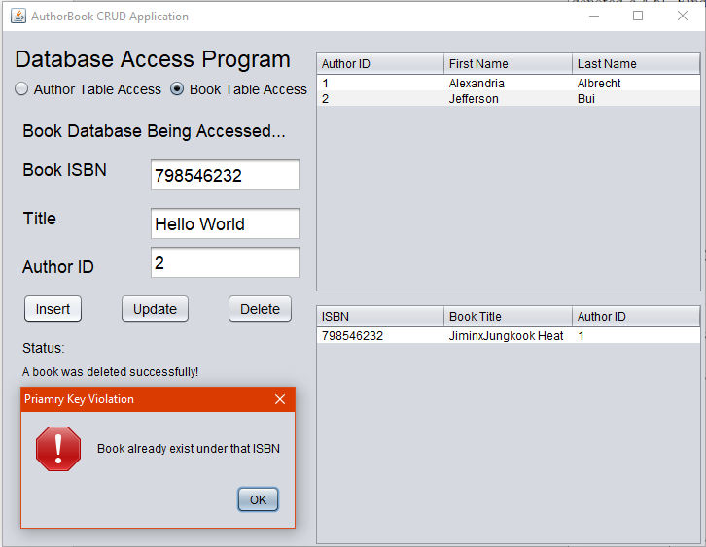

Added new book with existing ISBN for a primary key violation.

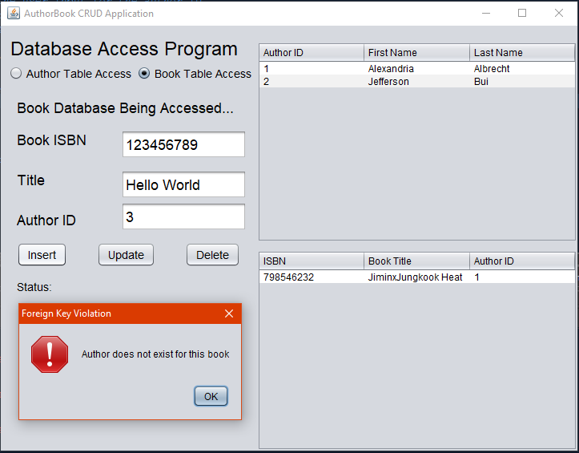

Added new book in Book table without an existing author in Author table and returned foreign key violation.